**Project Four – Power in Community:**

**Solving an Open-Ended Design Problem**

*ENGINEER 1P13 – Integrated Cornerstone Design Projects*

Tutorial T05

Team Tues-26

Jackson Lippert (lippertj)

Ahmed Mohamed (mohaa97)

Borna Sadeghi (sadegb1)

Andrew Krynski (krynskia)

Due: April 15, 2021

***Table of Contents***

Academic Integrity Statement 3

Executive Summary 4

Introduction 4

Conceptual Design 5

Final Proposed Design 6

Design Description 6

Device Parts 7

How the Design Meets Objectives 10

Conclusions 11

References Used in Report 12

Appendices: 12

Section 1 12

Section 2 13

Section 3 17

Section 4 36

Preliminary Gantt Chart 36

Final Gantt Chart 36

Logbook of Additional Meetings and Discussions 37

Meeting Agendas 40

Section 5 41

Source Materials Database 41

Academic Integrity Statement

The student is responsible for performing the required work in an honest manner, without plagiarism and cheating. Submitting this work with my name and student number is a statement and understanding that this work is my own and adheres to the Academic Integrity Policy of McMaster University.

Borna Sadeghi 400315188



The student is responsible for performing the required work in an honest manner, without plagiarism and cheating. Submitting this work with my name and student number is a statement and understanding that this work is my own and adheres to the Academic Integrity Policy of McMaster University.

Jackson Lippert 400311584

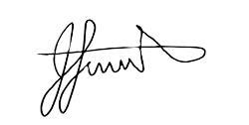

The student is responsible for performing the required work in an honest manner, without plagiarism and cheating. Submitting this work with my name and student number is a statement and understanding that this work is my own and adheres to the Academic Integrity Policy of McMaster University.

Ahmed Mohamed 400343870

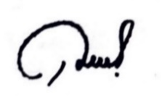

The student is responsible for performing the required work in an honest manner, without plagiarism and cheating. Submitting this work with my name and student number is a statement and understanding that this work is my own and adheres to the Academic Integrity Policy of McMaster University.

Andrew Krynski 400303486

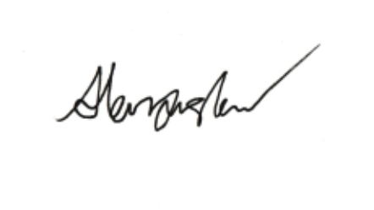



Executive Summary

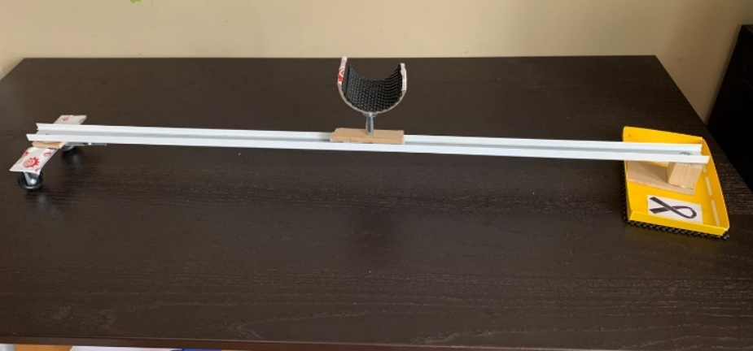For this project, we were faced with an open-ended design problem which we had to solve for a client. The client expressed trouble in the form of pain, fatigue, and general discomfort in her arms and leading into her hands while in her place of residence.  This affects her on a day-to-day basis in her home, and therefore is the most prominent issue that needs to be solved to improve quality of life for our client. Our group decided that the best course of action was to ease the pain associated with painting, since painting greatly improved her enjoyment of life. Our final prototype as seen in Figure 1 is a sliding rail system which supports her arm as she paints so that she does not spoil her painting. This device reduces pain in her arm and upper body by keeping her arm elevated, so she does not have to do it herself. This prototype solves the problem by improving quality of life for our client, as was an overarching goal for the motivation behind his project (Figure 2). This prototype benefits the client by conforming to many of the requirements outlined in the client notes, such as the need for comfortability (Figure 3). Currently in the market, there is no device such as this one which does the same thing, making our device unique and innovative. Finally, if we had more time and money to invest in this project, we would have liked to integrate other mechanical advantages into the design, such as hydraulics and robotics which would make our device usable on both horizontal and vertical surfaces (i.e., easel).

Figure 1: Final Prototype

Introduction

Our client is a retired midwife, and the mother of multiple children. In the past few years, she has developed passions in visual arts, as well as gardening, Brazilian Jiu Jitsu, and yoga, but these interests of hers, as well as essential abilities such as preparing meals and cleaning her house, have been hindered as a result of multiple physical disabilities. Previously, she had been a survivor of breast cancer, and it is evident that one of her surgeries had caused damage to her lymphatic system as she has been diagnosed. Lymphedema is a buildup of fluid known as lymph (which normally carries foreign material and bacteria away from bodily tissues), that results in swelling in the soft tissues of a limb [1]. The condition is lifelong, although it can be remedied in the short term with compression therapy, which our client applies frequently (our upcoming design solution takes advantage of this fact) [2]. This swelling may result in pinched nerves in the axilla, restricting fine movements in the client’s limbs [3]. The client’s day-to-day life is also affected by both ankylosing spondylitis and fibromyalgia. Her ankylosing spondylitis leads to lower back pain, fatigue and stiffness, especially after periods of inactivity. This makes it difficult for her to perform tasks that involve flexibility, such as gardening. Similarly, fibromyalgia takes its toll on the client through pain and stiffness in soft tissues around the body, especially in the muscles that control the hands [4].

In summary, the client expresses trouble in the form of pain, fatigue, and general discomfort in her limbs, back, and hands while in her home, which affects her on a daily basis and therefore is the most prominent issue that must be solved, constituting our problem statement. She spends a lot of time engaging in her painting hobby, and the goal of this project is to liberate her from the disabilities that prevent her from doing so. The objectives are to ease pain associated with movement, add predictability to her routine, and make her usual tasks easier for her to accomplish. The solution must be reliable, easy for the client to use, and result in a noticeable increase in her quality of life. Additionally, although less important, the design should be simple and thus easy to understand and repair, and also cost effective, to make it more feasible.

Currently, there are no products in the market that perform the same task that this design does in the same manner, however, inspiration was gathered from systems that can easily be moved in a fixed two-dimensional area, such as monitor arms, which also have the ability to bear a lot of weight.

Conceptual Design

Throughout the project we were required to put ideas into action by creating physical prototypes based on our ideas. To start the ideation process, we took note of the client’s main issues and needs (Figure 2) and based our design space on that. We took note of our group’s individual skills/abilities (Figure 4), then explored the design space using functional analysis (Figure 5). After we generated many ideas, we decided to break off and focus on coming up with a feasible idea that we may focus on to be a final prototype. We met up with our individual ideas and decided to use a weighted decision matrix to decide which design we were going to focus on (Figures 6,7). We came up with criteria for the decision matrix based on the objectives and constraints of the project, which gave us a good idea of which criteria were the most important for the design. The ideas we came up with (Figures 1,8,9) were compared with each other, and we decided that the sliding rail arm support idea was the best and most feasible. Even though the sliding rail arm support idea did not have the highest rating on our decision matrix, we used the decision matrix to analyze and create talking points about the devices. After refining the prototype and showing it to the TAs, they had little to say, giving feedback only on the aesthetic aspect of the prototype. We took the feedback and created a more ‘personalized’ version of the prototype, which showcased the engineering fireball and breast cancer ribbons in support of our client (Figure 1).

Final Proposed Design

Design Description

Our final proposed design is a streamlined version of our final prototype and is modeled and simulated in Autodesk Inventor [20]. The system uses a tracking system similar to that of a railway, as well as a modular component that allows the design to work on almost any horizontal surface of any size. The completed design model (Figures 24.1 – 24.3) uses a spring-loaded arm rest on an aluminum slider (Figure 29) to provide comfort to the client while using the system.

The axis track allows for canvas sizes of up to 89cm in one direction, as it expands from an internal width from 47.5cm to 89cm. The changeable width allows for use in/on multiple surfaces as well as changing canvas sizes.

To allow the armrest to slide, the design uses four rails, 2 on the female slider (Figure 16), and 2 on the male slider (Figure 18) for stability when sliding and also when transferring the sliding arm part (Figure 22) between the female and male sliders. The ends of the slider rails are rounded on the transferring edges of the male and female sliders to avoid jamming when transferring the sliding arm rest.

The ability for the system to be used on most surfaces is very important, and to do this a modular system was designed that provided 3 different types of end support, all with the same floor to rail distance so they can be mixed and interchanged between. All modules use a 2-pin system (Figures 11, 19) to connect to the ends of the female and male sliders, which is then held in place by a long pin (Figure 17) for the female slider, and a short pin (Figure 21) for the male slider. Both pins are made with a large easy grab handle for ease of use.

The first module uses castors (Figure 25) to provide a rolling function, as well as a second axis when used on both sides. This configuration would allow the client to reach and be supported on any part of the canvas. The castors are also free to rotate so that the design can be used with one end fixed, such that the design moves in a rotation motion with one end acting as the centre of rotation. This module is most effective on harder surfaces such as linoleum and hardwood, as well as thin carpet.

The second module (Figure 26) uses a stationary grip pad (Figure 20) to keep at least one end of the system stationary. An added function of the module acts as a holder for tools, paints, brushes, etc. for the client while she uses it. The pad connects to the pad module connector (Figure 19) by a rotational axis that allow the entire system to rotate. The pad connector then connects to the main sliders using the modular connector and pin. The pad module can either be used on one or both sides of the sliding system (Figure 28) depending on the client’s preferences and the surfaces available, although the surfaces must be flat.

The third module (Figure 27) uses a clamping system to hold one end of the rail system (Figure 28) to the end of a surface. It does this by using a threaded screw with a large handle (Figure 15) for easy manipulation, which is connected to a clamping pad (Figure 14) by a spherical lock which not only holds it in place but allows the pad to rotate in all directions to allow it to connect to the most obscure surfaces. The clamp connects to the rail system with the modular connector (Figure 19) with a single pin that also allows for the rotation of the rail system about the clamp when connected.

View [Figure 30](https://drive.google.com/file/d/1iYrfG0rWP9wvlDGAkfaaEysD6CJ14NVC/view?usp=sharing) for an animation of the system in Autodesk Inventor’s [20] dynamic simulation.

Device Parts

Armrest (Figure 9):

The armrest is crafted out of aluminum for its strength in the thinner parts where other materials would bend or break. The inside of the armrest contains a soft silk padding to add maximum comfort and cooling for the client’s wrist with the hope that it will extend the amount of time being used. The Armrest connects to the sliding part (Figure 22) by a cylinder which is loaded with a spring (Figure 23) to add a bit of vertical adjustability.

Sliding Part (Figure 22):

The sliding part is built of polished aluminum for its durability, and its ability to slide on the rails of the sliding system (Figure 28). It has 4 holes that lock it onto these sliders. The outside holes are for when the slider is connected to the female slider (Figure 16), and the inside holes are for when the slider is connected to the male slider (Figure 18). The sliding part holds the armrest through a spring-loaded chamber.

Spring (Figure 23):

The spring is built from a soft steel to avoid breaking and cracking over time of usage. The spring sits between the armrest (Figure 9) and the sliding part (Figure 22) to act as a vertical adjustment for the user as well as added comfort.

Female Slider (Figure 16):

The female slider is a mostly aluminum construction to stay strong while being lightweight, and to avoid cracking in the thinner spots of the part. The rails on the part connect with the outer holes of the sliding part (Figure 22) and the male slider (Figure 18) fits directly into the female slider. The modular connector on the slider is built out of wood as it is strong when solid and lighter than metal. The ends of the rails are rounded to allow for a smooth transition of the sliding part between the male and female sliders.

Male Slider (Figure 18)

The male slider is built mostly out of wood and inserts directly into the female slider (Figure 16). Due to its solid construction and large size, the rectangular portion of the part is built out of wood for high strength and low weight. The rails on the part are made of polished aluminum and fit into the inner holes of the sliding part. The ends of the rails are rounded for a smooth transition between the female and male sliders. The part contains the same modular connector as the female slider allowing for interchangeable modules.

Castor Mount (Figure 11):

The castor mount is what connects the castor arms (Figure 10) to the male and female sliders (Figures 18, 16 respectively) by two aluminum pins that fit into sized holes that is then fixed in place by either the long or short pin which is inserted perpendicularly to the two aluminum pins. The castor arms are connected through two holes in the bottom of the part that allow free rotation. The part is made from wood for its solid construction while being lightweight and strong.

Castor Arm (Figure 10):

The castor arms are made from a steel construction due to its strength in small sizes. The post of the castor arm fits into the holes in the bottom of the castor mount (Figure 11). The castor wheels (Figure 12) fit on the axle of the castor arm.

Castor Wheel (Figure 12):

The castor wheel is built from rubber coated plastic to stay lightweight while maintaining a good grip on whatever surface it is on with minimal slippage. The castor wheel connects to the castor arm (Figure 10) through the axle hole on the axle of the arm.

Pad Connector (Figure 19):

The pad connector is built from aluminum for its strength while being lightweight. The part has two large pins on the top that allow it to connect to the modular connector on the female and male sliders (Figures 18, 16 respectively). There is a pin connector in the base of the part to connect to the clamp frame (Figure 13) and pad (Figure 20). This pin allows the rotation of the entire system about the part.

Clamp Frame (Figure 13):

The clamp frame needs to hold the force of a tightened clamp, and therefore is built from mild steel. Although this is heavier, it is a smaller part and will not make much difference. The top of the clamp frame connects to the pad connector (Figure 19) which allows the clamp frame to rotate. The clamp frame holds a clamp screw (Figure 15) that applies pressure to the top of the clamp that has a rubber pad to prevent slipping and damage to the surface that it is clamped to. It also contains a steel rib to help support the compression force of the clamp.

Clamp Screw (Figure 15):

The clamp screw attaches by thread to the clamp frame (Figure 13). The clamp screw is made from nickel coated hardened steel to prevent warping of the threads from the compressive force of the clamp. The clamp screw has a long rubber coated arm which allows for easy turning of the screw and plenty of leverage so not much force is needed to tighten the clamp. The top of the clamp screw is spherical to connect to the clamp pad (Figure 14) while allowing it to freely rotate.

Clamp Pad (Figure 14):

The clamp pad is made of mild steel to prevent warping and has a rubber pad on the top to reduce slippage and increase clamping ability. The bottom of the clamp has a spherical slot to connect to the clamp screw (Figure 15) and allow free rotation of the clamp pad.

Pad (Figure 20):

The pad is built from an aluminum and wood construction and has the purpose of securing the system to a flat surface. The tray of the pad is built from wood for its light weight and its strength. The underside of the wooden tray is lined with rubber to reduce slipping on flat surfaces. The aluminum shaft of the part connects the wooden tray to the pad connector (Figure 19) that allows free rotation of the system when connected.

Short/Long Pin (Figures 21, 17 respectively):

The short and long pins connect any of the modules (Figures 25, 26, 27) to the male and female sliders (Figures 18, 16 respectively). The pin is made from mild steel for its strength as the part is thin. The handle of the pin is made from rubber coated aluminum for lightweight and its ease to grip the large handle. The short pin is used in the male slider and the long pin is used in the female slider

How the Design Meets Objectives

Objective 1: Ease pain associated with movement of the client. Metric: Pain scale of 1-10

The proposed design in practice will be able to ease the pain caused by the client’s challenges by reducing the overall stress on her body while painting. This will allow her to paint for longer periods of time which will not only make it more efficient but will also provide a moral boost. We plan to measure this by reading her pain scale while using the device and not using the device.

Objective 2: Add predictability to day-to-day life of the client. Metric: Consistent ratio of planned to completed tasks

The design can help add predictability to day-to-day life by aiding in the reduction of pain. If the client is painting in a comfortable position, there will be less pain throughout the day that had previously been caused by discomfort from painting. This can be measured by calculating the ratio of planned to completed tasks before and after the device is introduced in to daily life.

Objective 3: Make general problematic tasks easier to accomplish for the client. Metric: Average time to complete tasks

Assuming that the design can reduce overall pain, this will allow the client to complete other tasks in a faster time frame. We can measure this by recording time to complete daily tasks on several occasions before and after the device has begun being used.

Conclusions

Currently, the team is in the prototype iteration phase. Thus, in order to make further progress, one of the next steps are to test the prototype in a more meaningful way; allowing the client to try the mechanism herself, and gauging her level of satisfaction in our criteria. This will give our team plenty of further insight into the client’s desires, and is advantageous since all of our objectives are centered on our client’s satisfaction, and because there were few opportunities to communicate with the client to refine our idea with. The testing plans that we have composed will also need to be brought into fruition, such as the “non-slip test”, which checks the ability of the wheels and non-slip pad to stay stationary when they are supposed to, and prevent slippage from beneath the user. New tests can be developed if we gather more information regarding what works for our client and what does not.

Over the course of the project, much of the team’s work was done individually, with tasks delegated to each team member. This approach is effective in some circumstances, but is missing a significant aspect of communication, that is, peer feedback at every step in the process. This leads to the team meetings being sparse of content, as most of the brainstorming is done as individuals working on a subtask outside of meeting time. Reflecting on this, it appears that despite our work ethic as individuals, the team should strive to enhance precise communication interweaved with our working routine moving forwards. One way to achieve this is to have the project manager assign tasks to multiple group members instead of one, promoting discussion in the sub team, similarly to how the teams were split into graphics and computing sub teams in previous ENGINEER 1P13 design projects. Another way to improve communication in regards to the engineering design process is by creating a standard structure by which the team meetings are to be held. For example, the manager should create a meeting agenda before the meeting is held in order to justify its purpose and keep the meeting on track. In hindsight, having this plan in place will allow for more effective meetings that are concise and allow everyone to understand the status of the project and how it is moving forward.

References Used in Report

[1] “Lymphedema”, *Harvard Health Publishing*. Dec. 2018.

[2] K. Johansson, K. Ochalek, and S. Hayes, “Prevention of arm lymphedema through the use of compression sleeves following breast cancer: results from a targeted literature review,” *Physical Therapy Reviews*, vol. 25, no. 4, pp. 213–218, Jul. 2020.

[3] S. Klonisch, Sobotta Clinical Atlas of Human Anatomy, one volume, English, 2019.

[4] M. Pérez-de-Heredia-Torres, R. M. Martínez-Piédrola, M. Cigarán-Méndez, R. Ortega-Santiago, C. Fernández-de-las-Peñas. “Bilateral deficits in fine motor control ability and manual dexterity in women with fibromyalgia syndrome”. Experimental Brain Research, vol. 226, pp. 137–143. January. 2013. doi: <https://doi.org/10.1007/s00221-013-3417-4>

Appendices:

Section 1

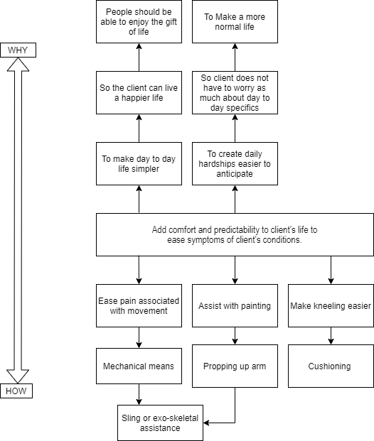

Figure 2 : How/Why Ladder

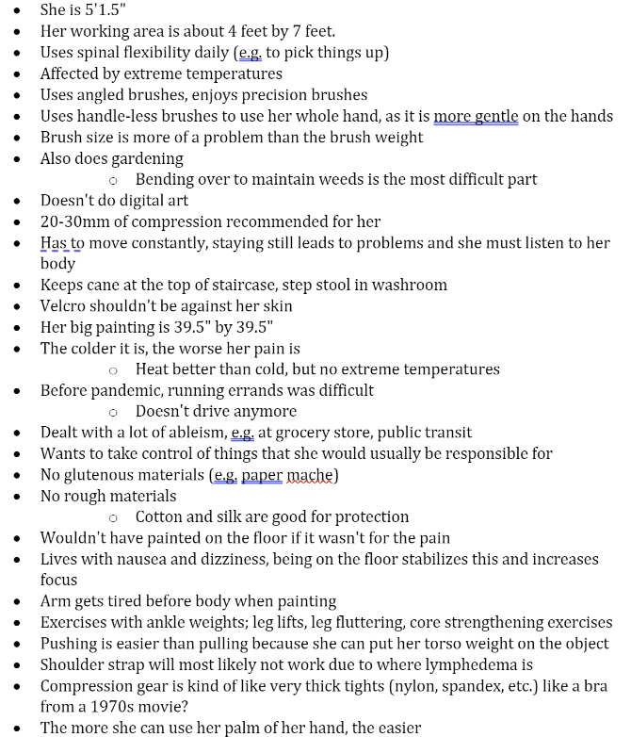

Figure 3: Some Client Notes

Section 2

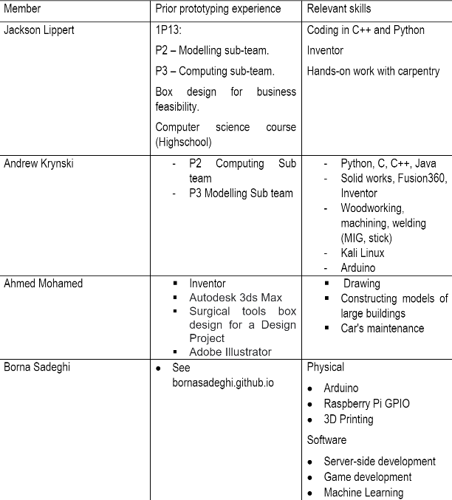

Figure 4: List of relevant skills

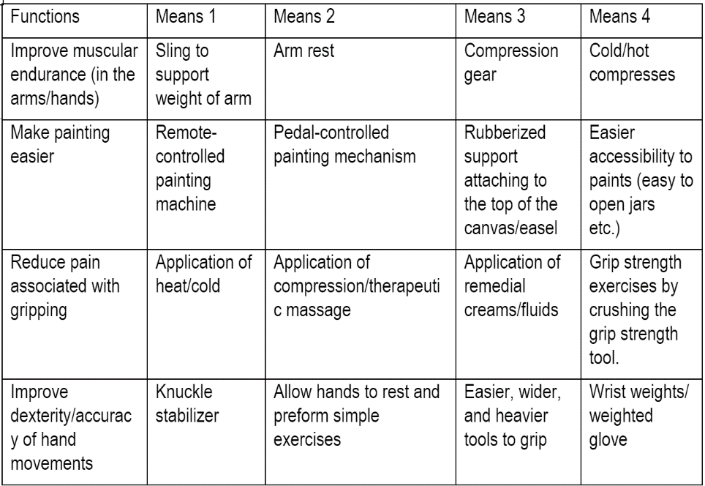

Figure 5: Functional Analysis

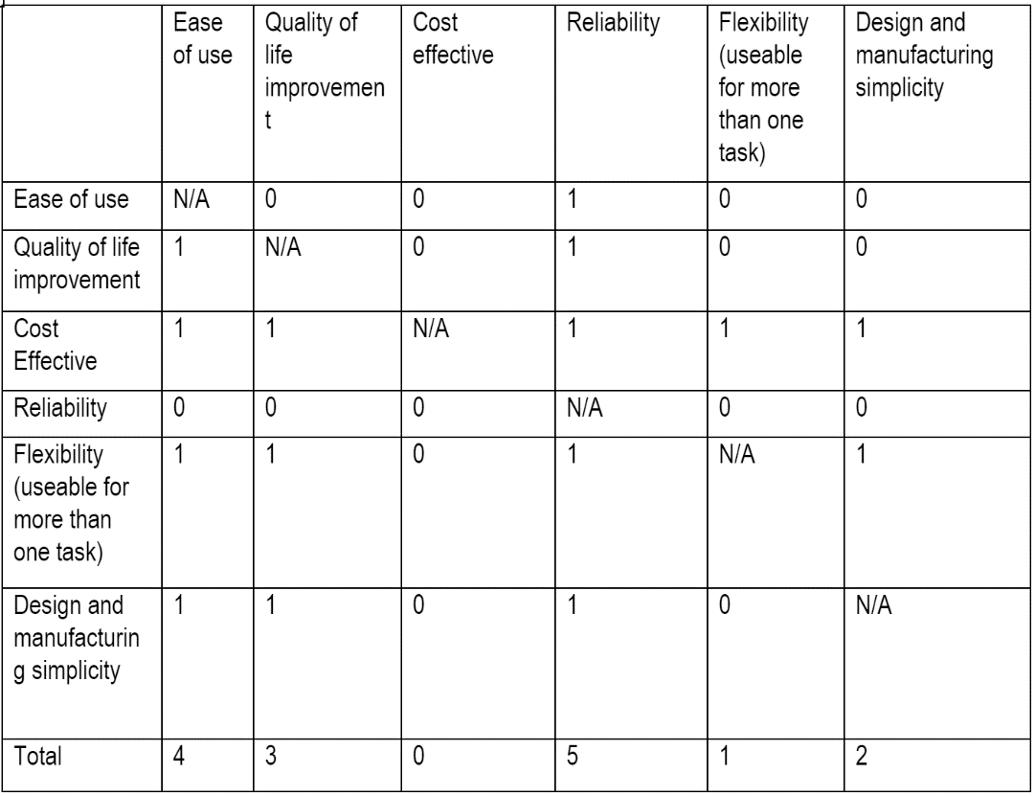

Figure 6: Decision Matrix for Criteria

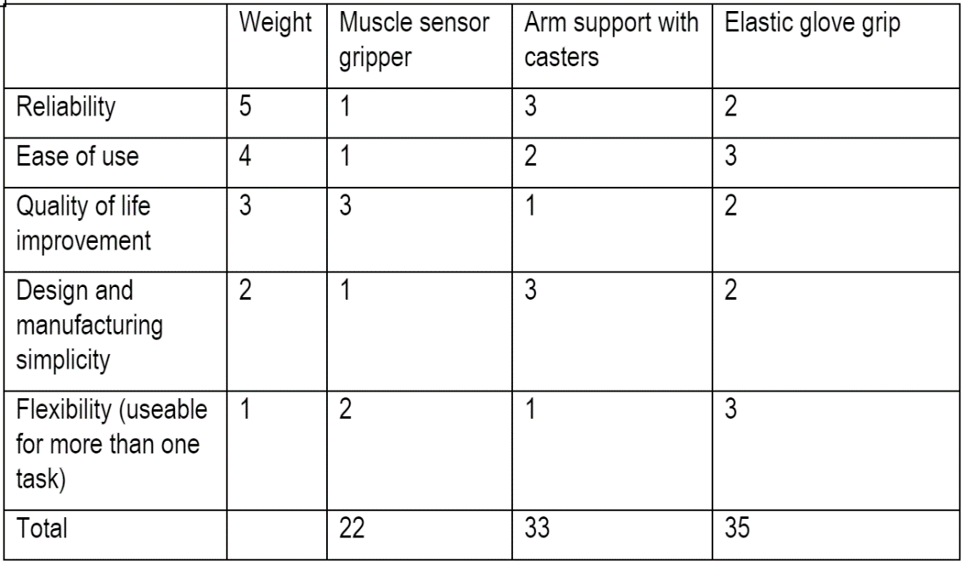

Figure 7: Weighted Decision Matrix

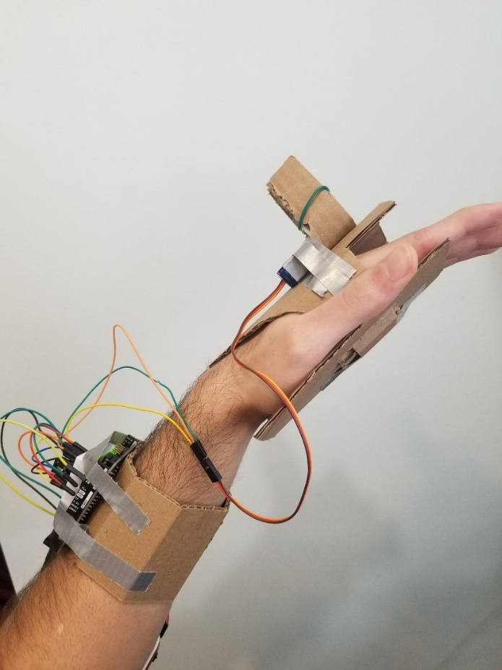

Figure 8: Borna's Prototype

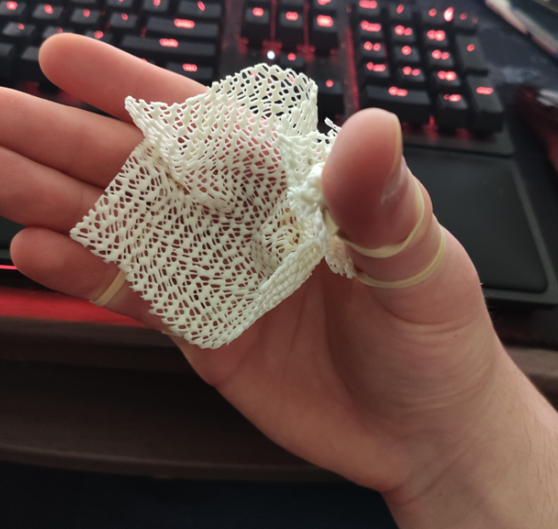

Figure 9: Andrew's Prototype

Section 3

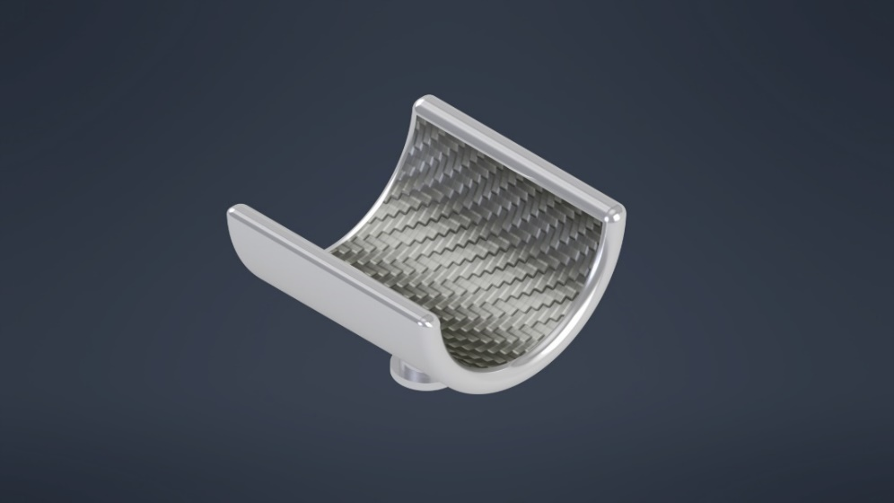Figure 9.1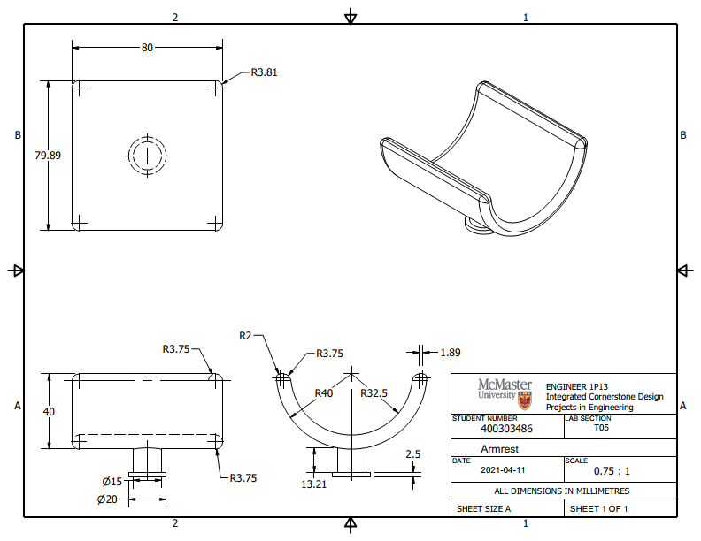

Figure 9.2

Figure 10.1

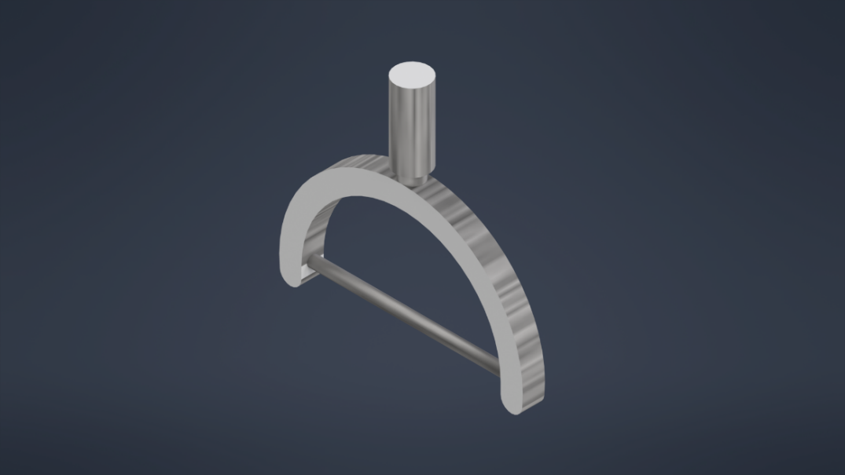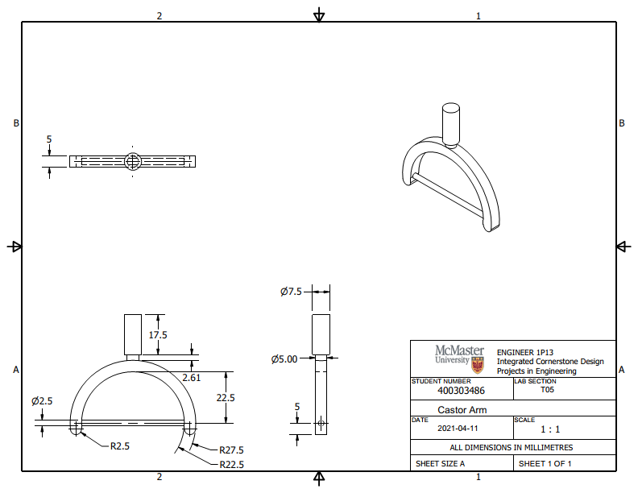

Figure 10.2

Figure 11.1

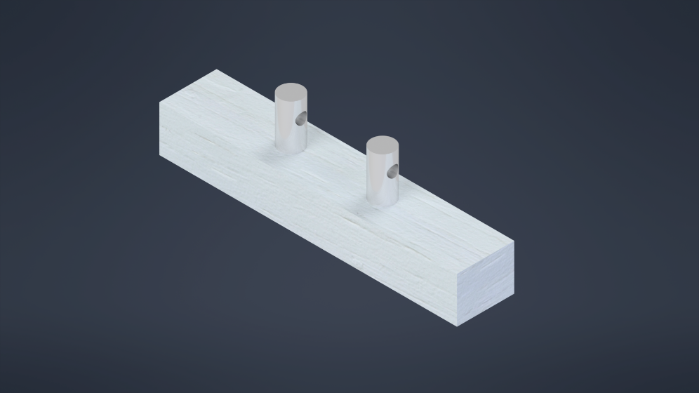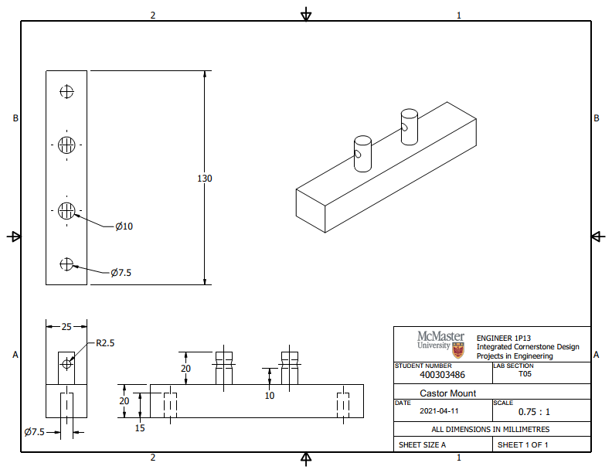

Figure 11.2

Figure 12.1

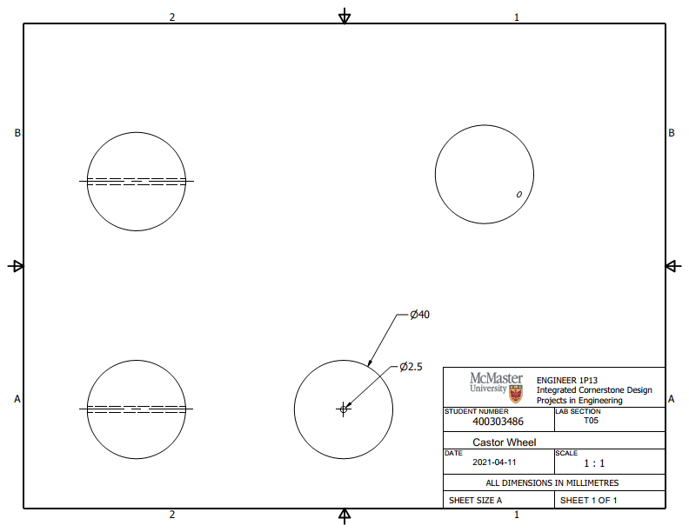

Figure 12.2

Figure 13.1

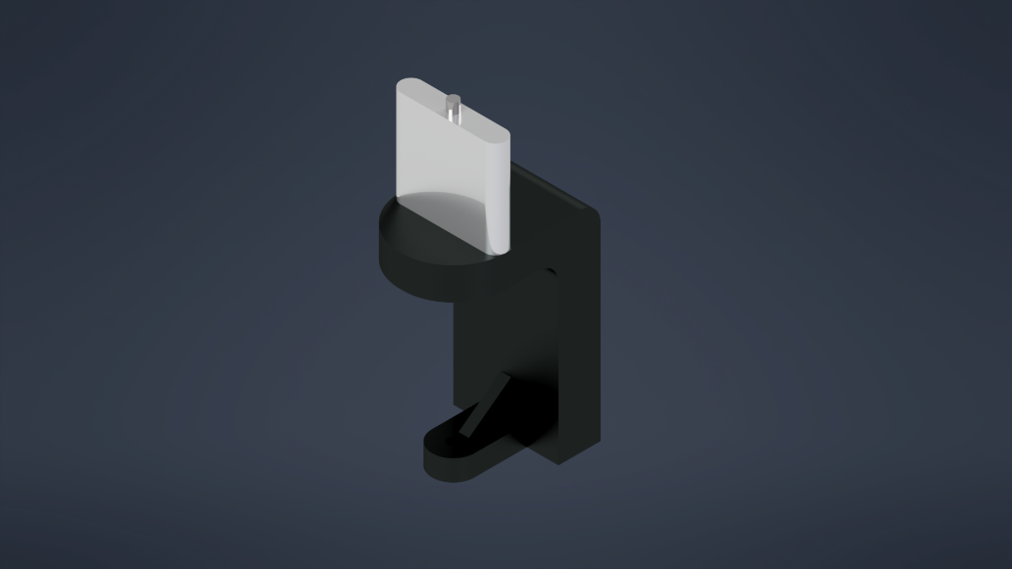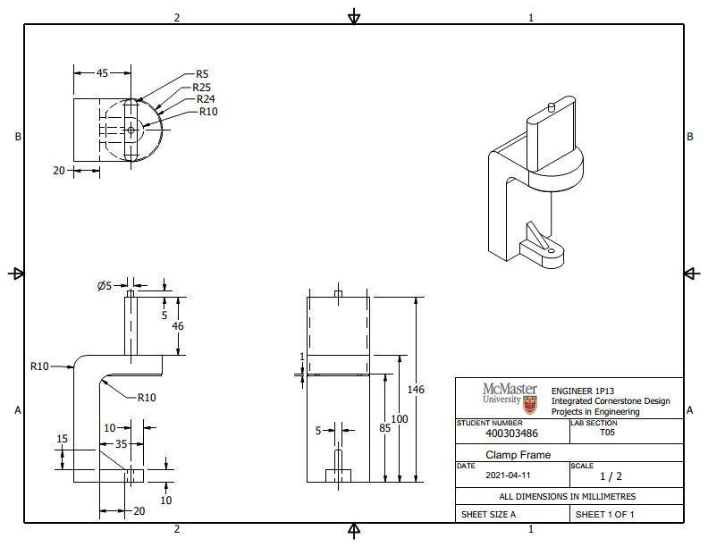

Figure 13.2

Figure 14.1

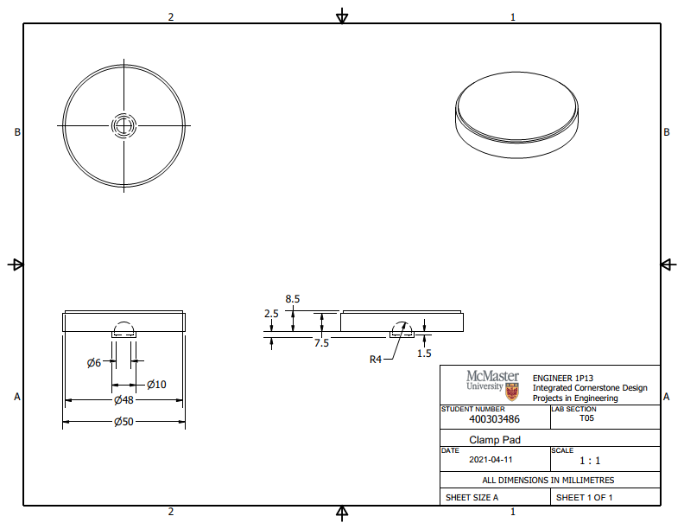

Figure 14.2

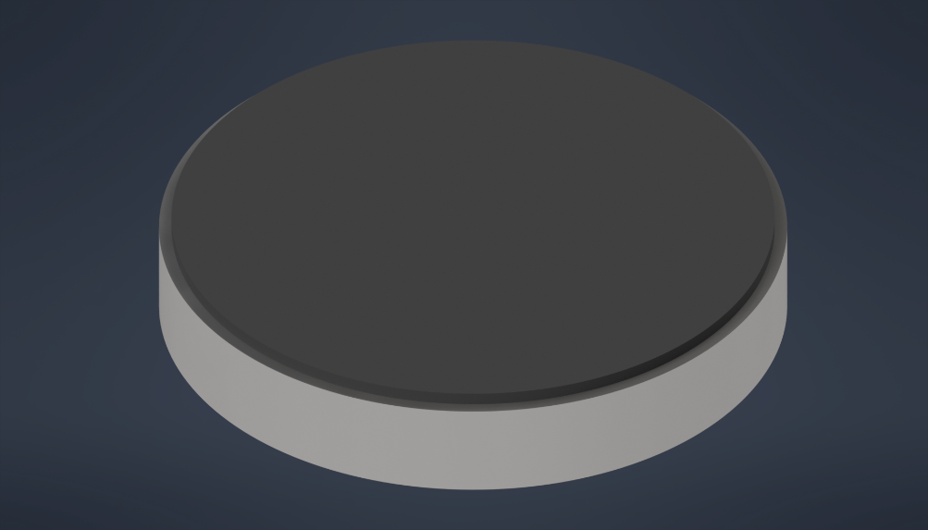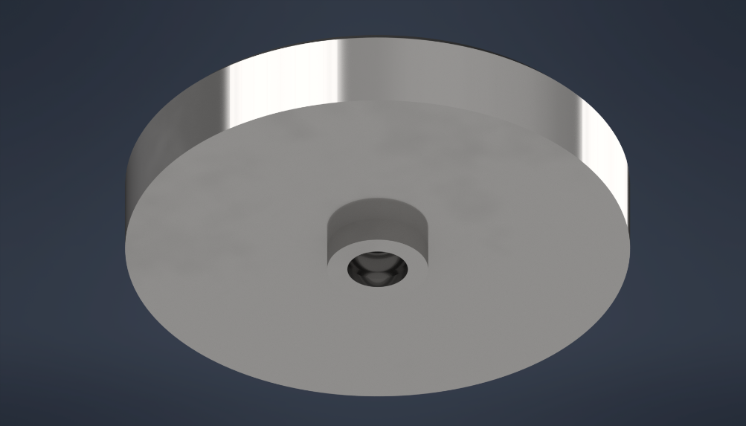

Figure 15.1

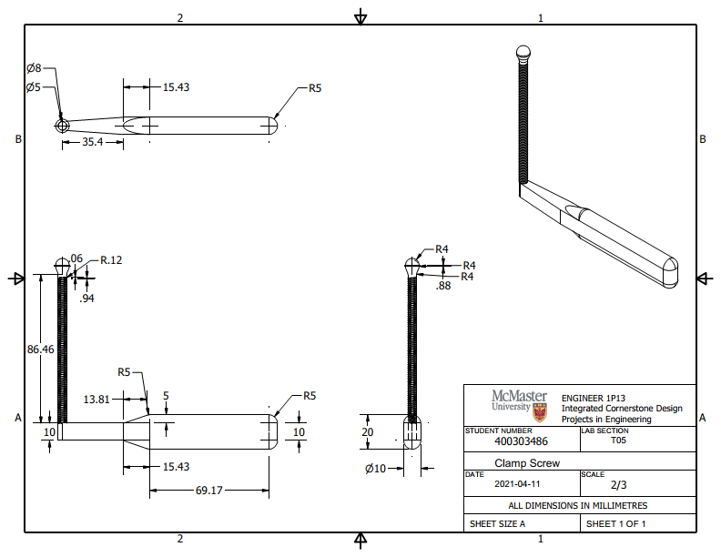

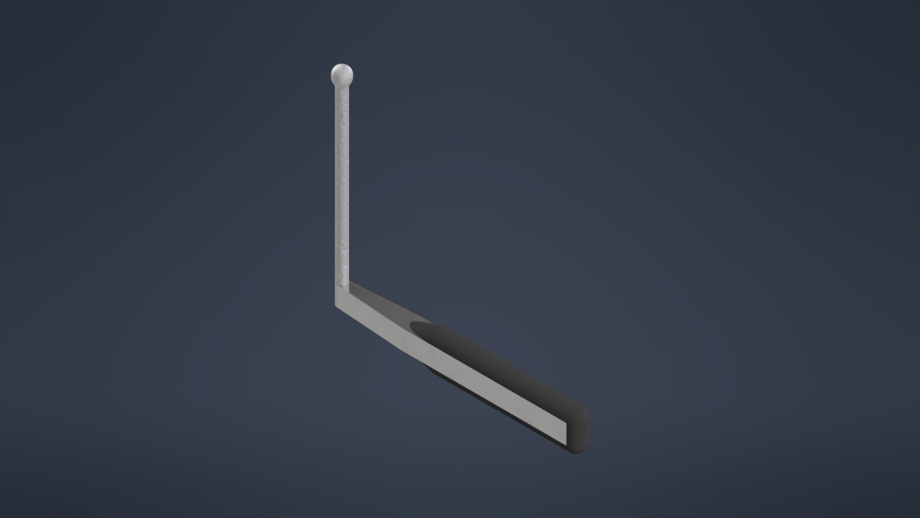Figure 15.2

Figure 16.1

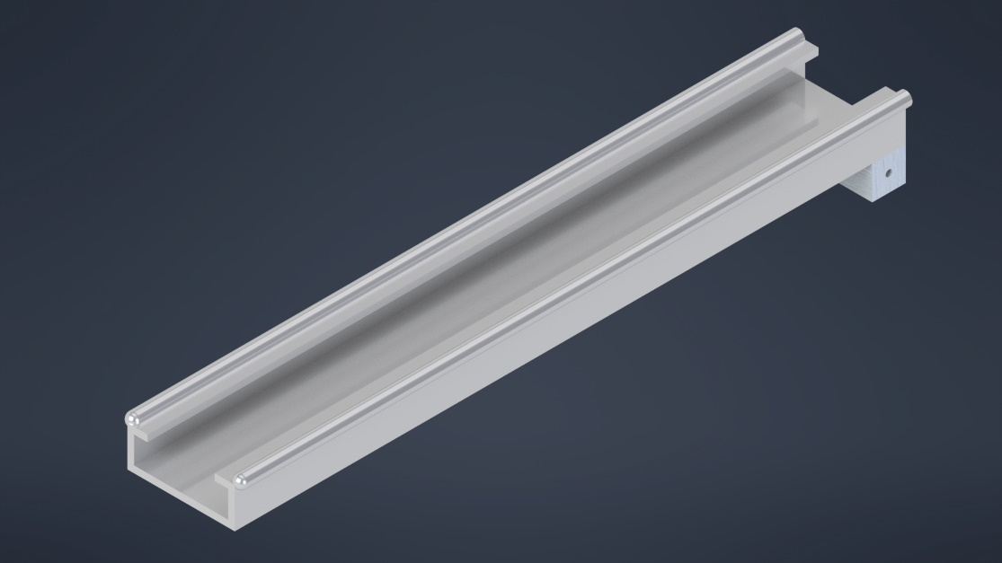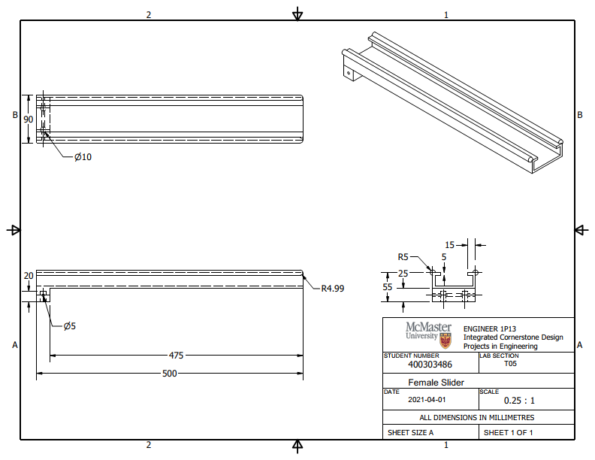

Figure 16.2

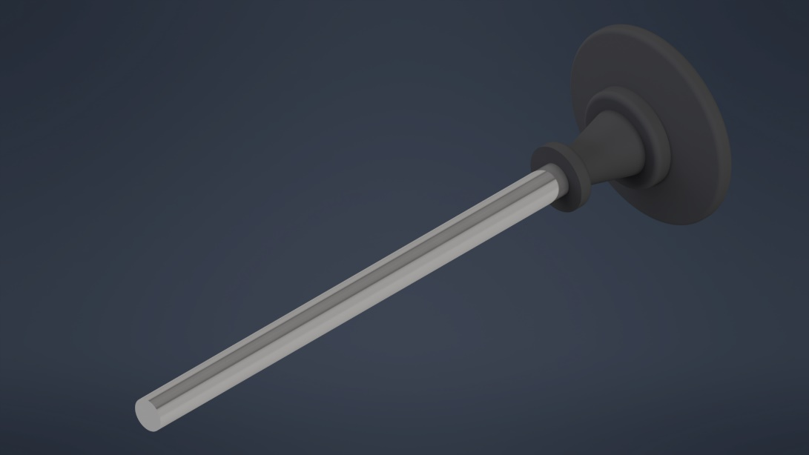Figure 17.1  
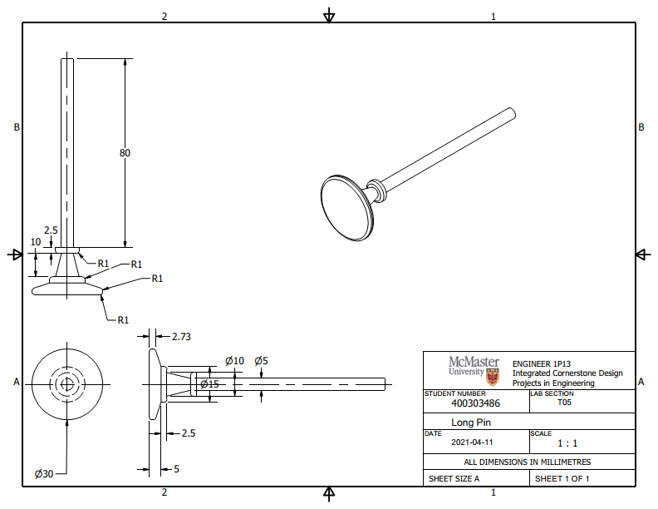

Figure 17.2

Figure 18.1

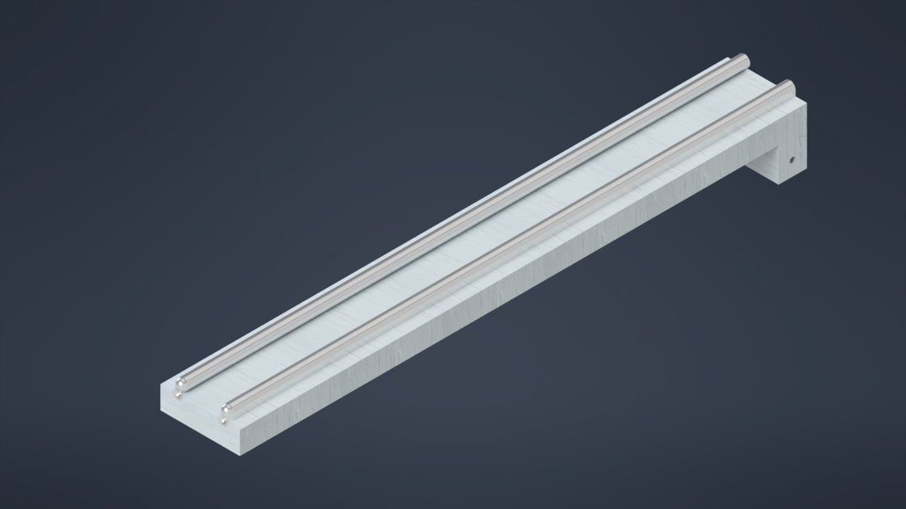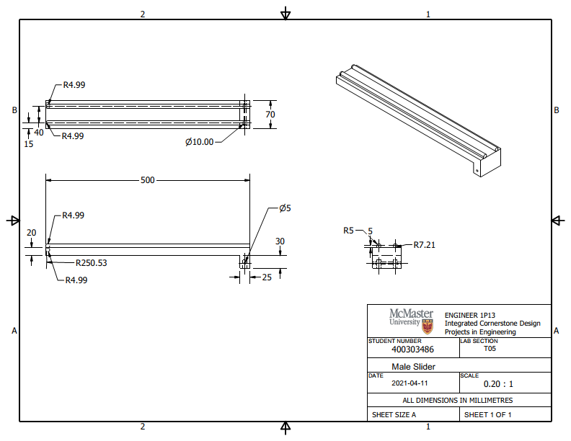

Figure 18.2

Figure 19.1

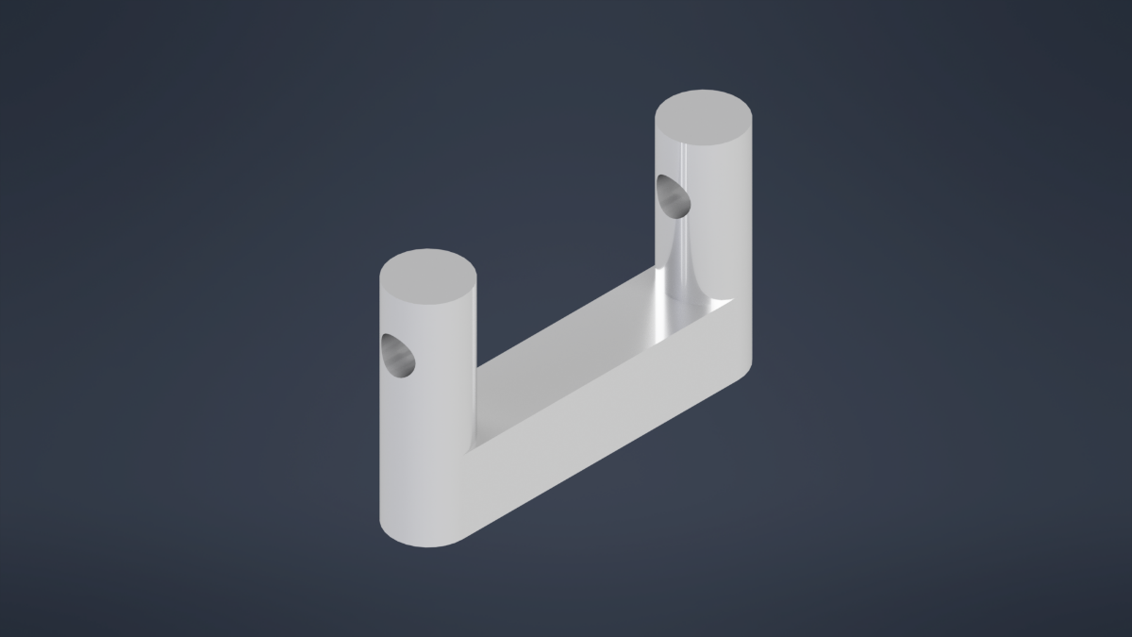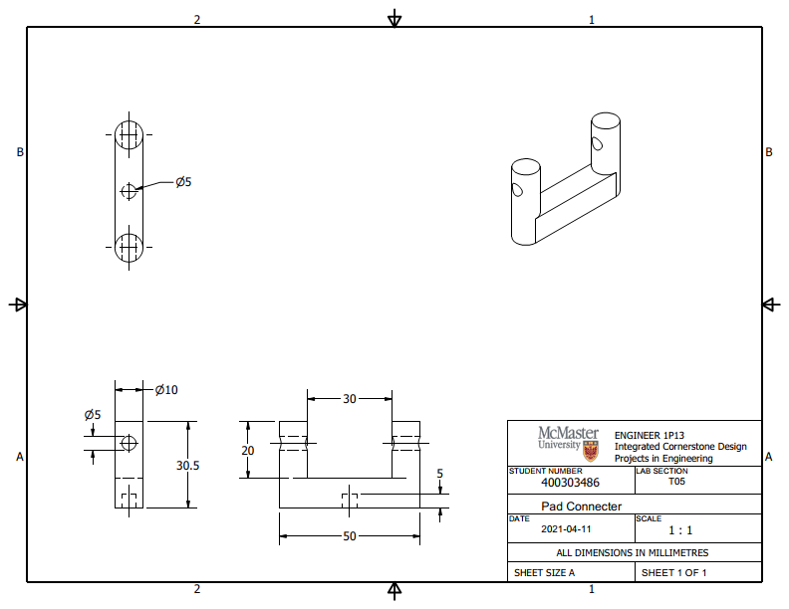

Figure 19.2

Figure 20.1

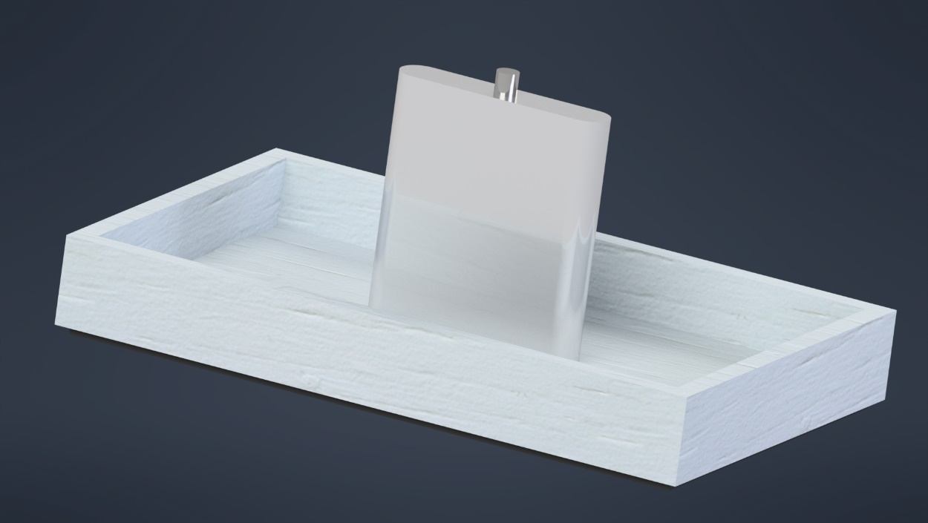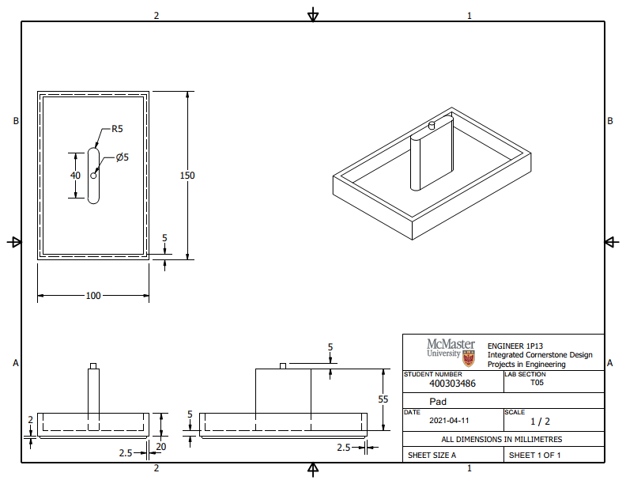

Figure 20.2

Figure 21.1

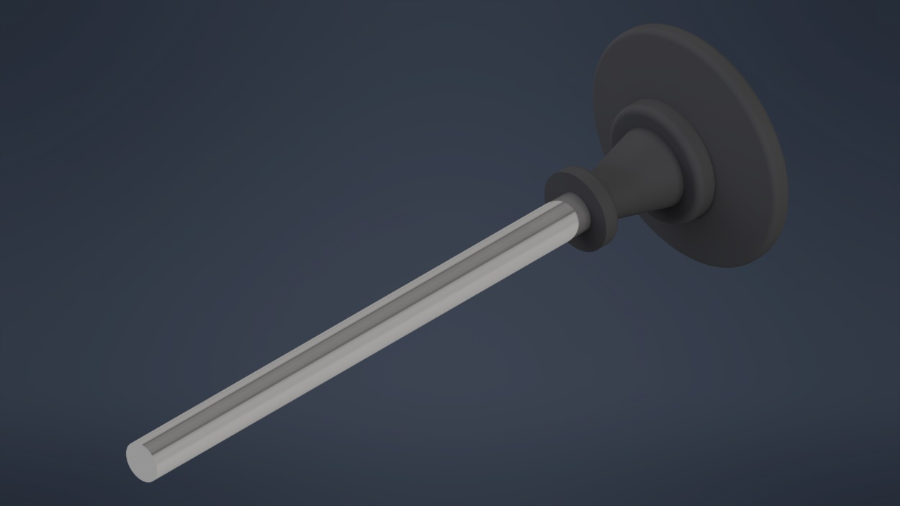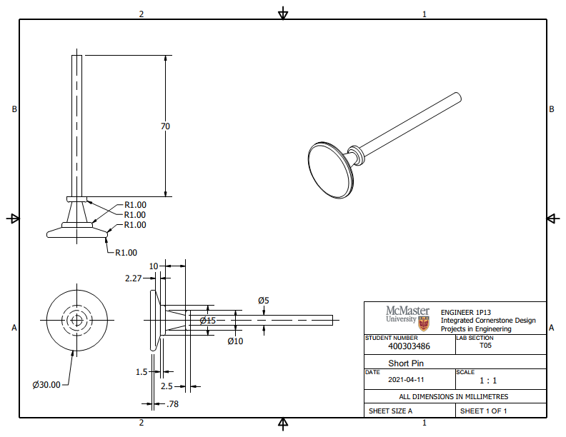

Figure 21.2

Figure 22.1

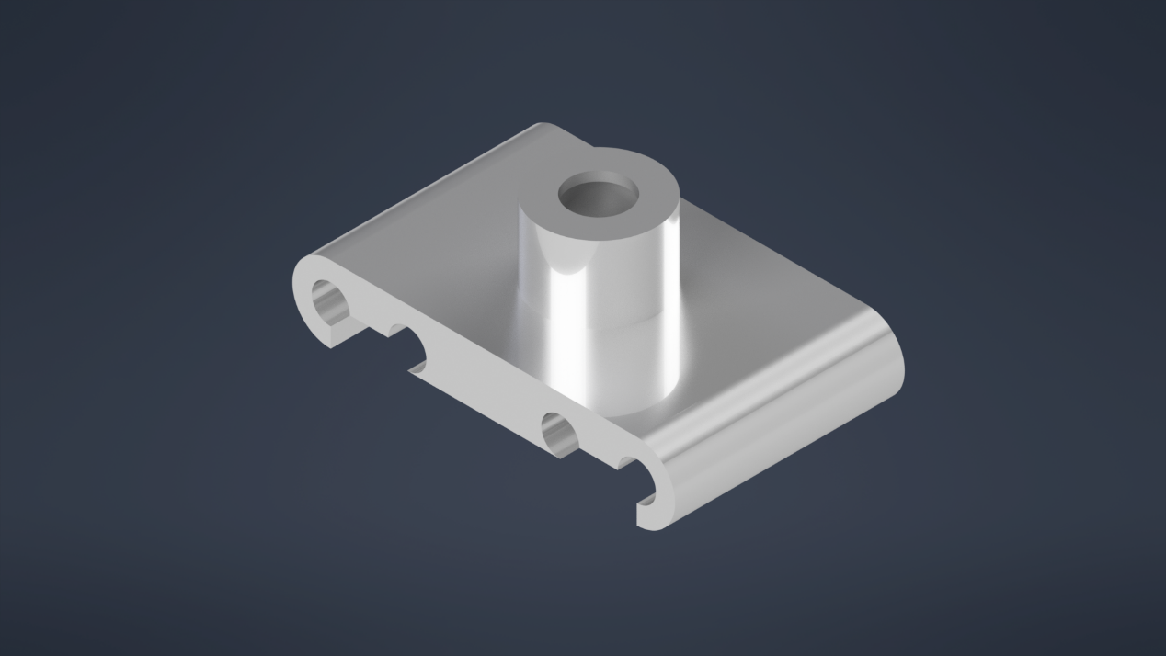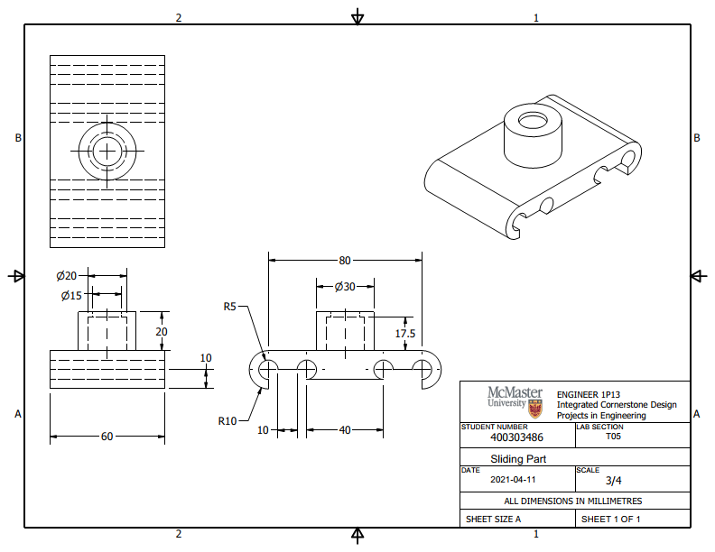

Figure 22.2

Figure 23.1

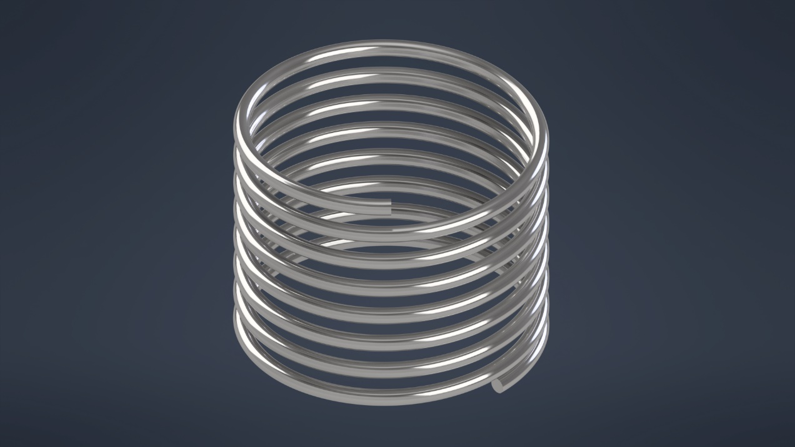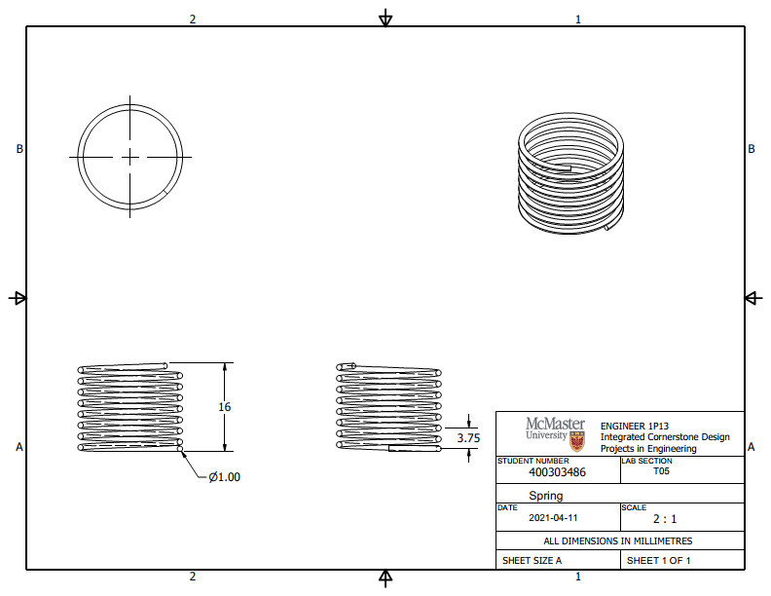

Figure 23.2

Figure 24.1

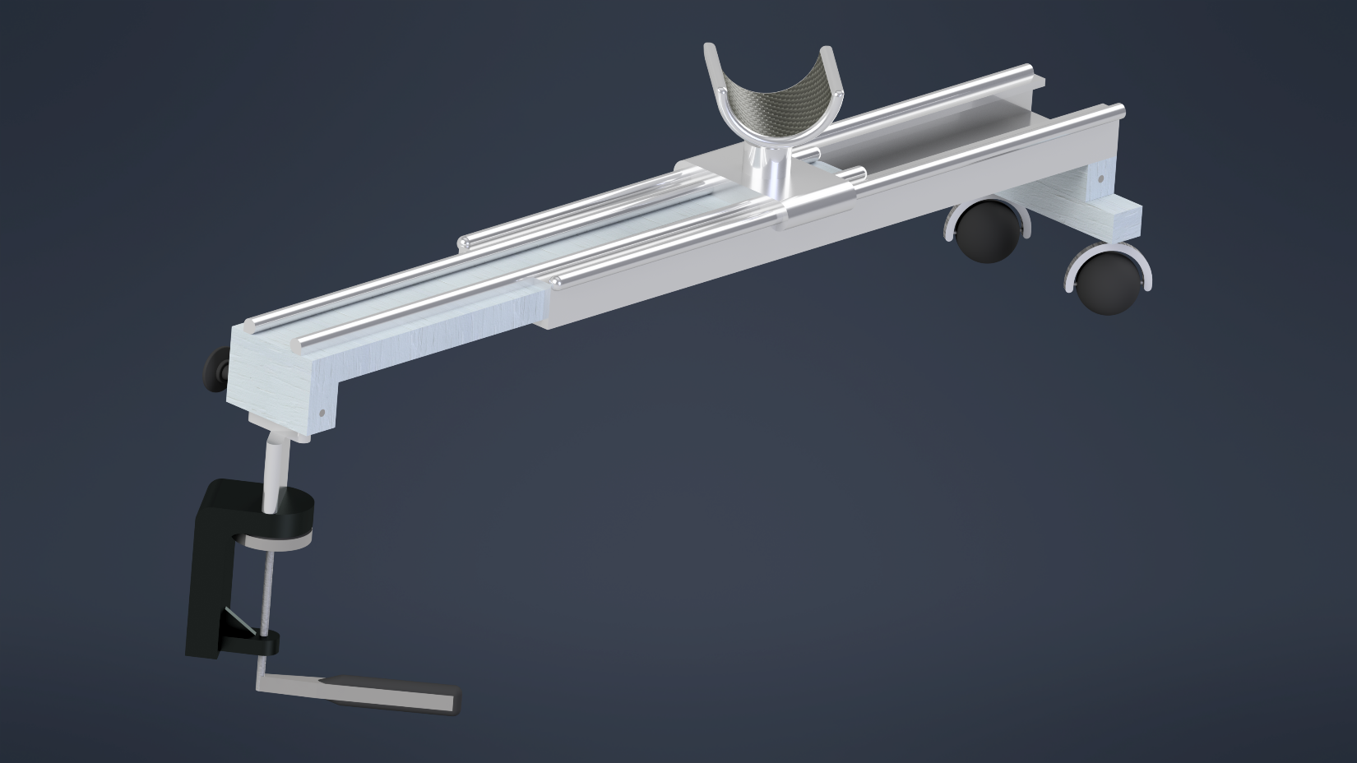

Figure 24.2

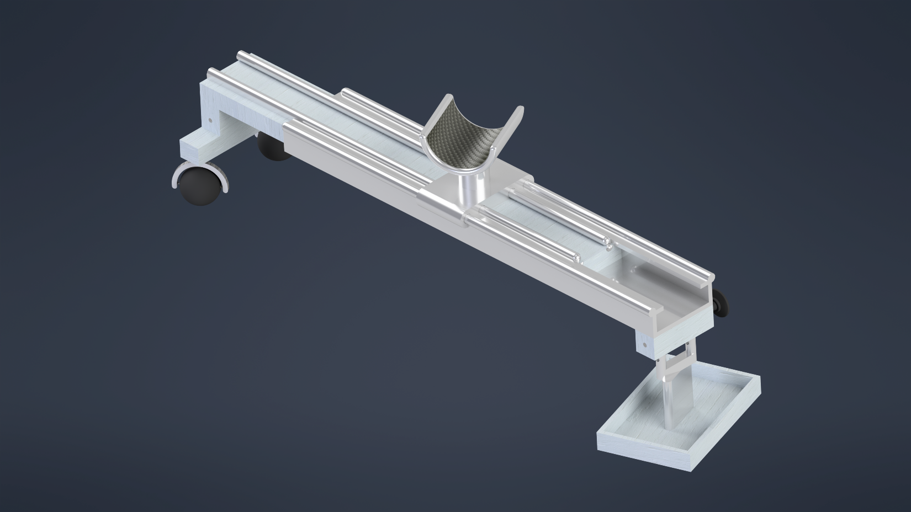

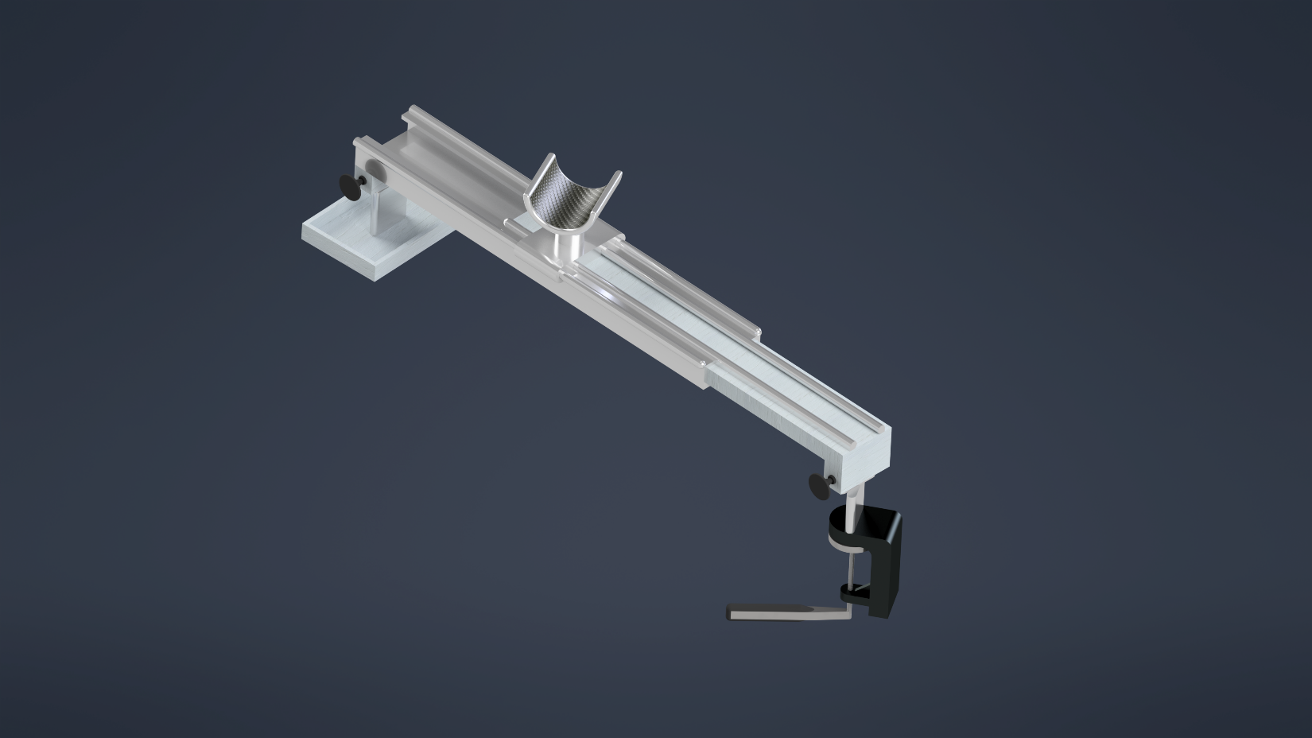Figure 24.3

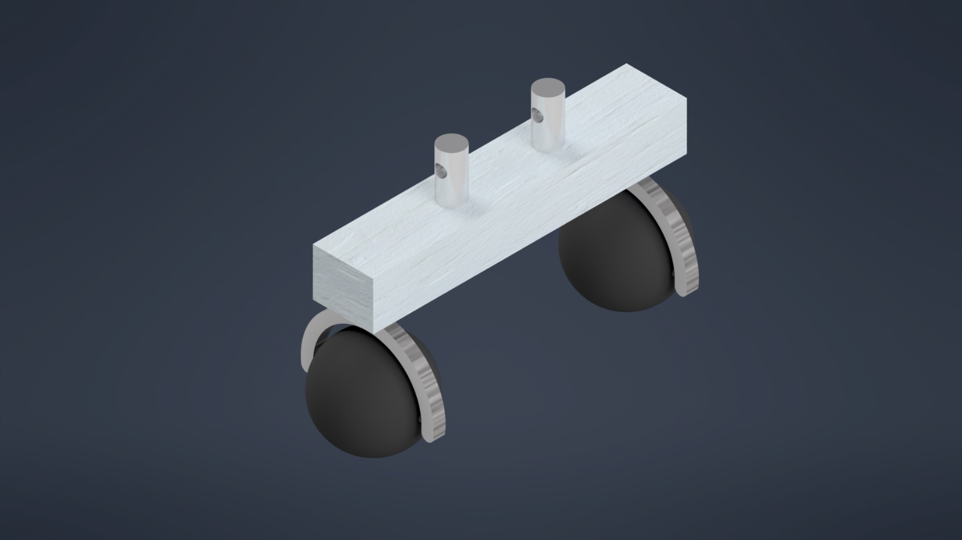Figure 25

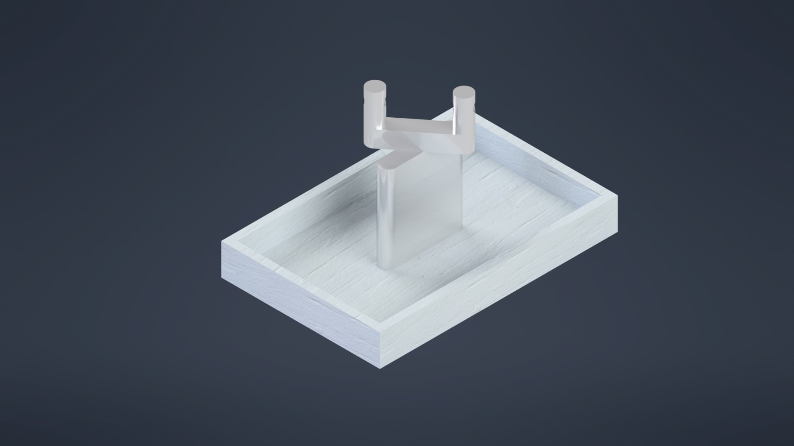Figure 26

Figure 27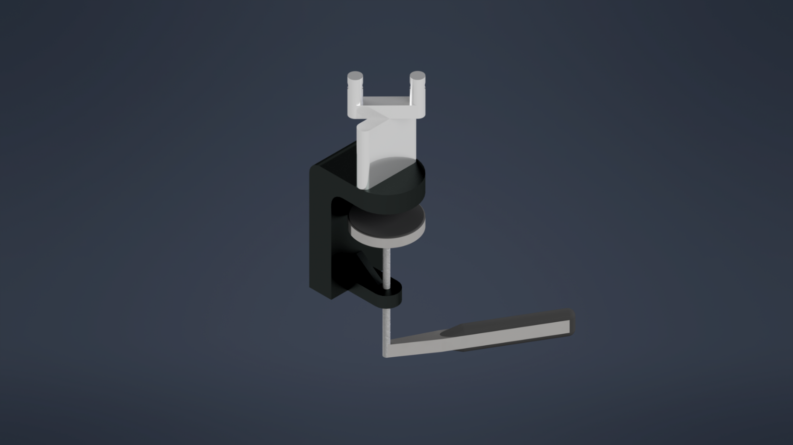

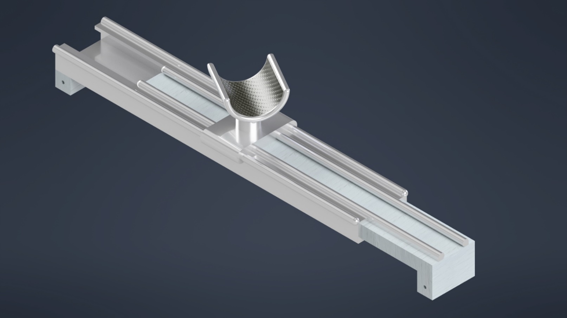Figure 28

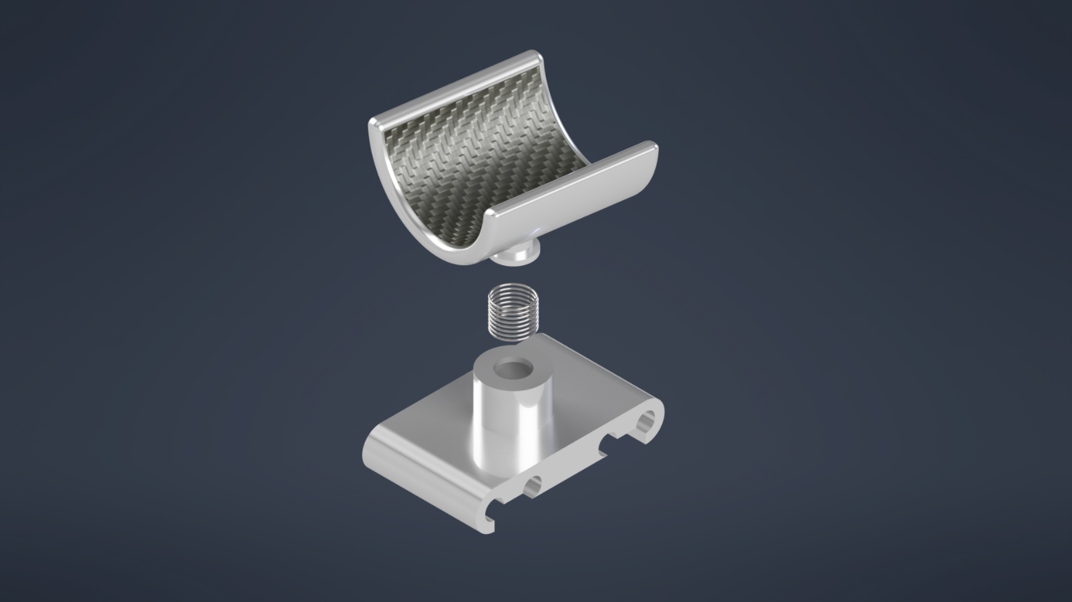Figure 29

**Figure 30:** [**https://drive.google.com/file/d/1iYrfG0rWP9wvlDGAkfaaEysD6CJ14NVC/view?usp=sharing**](https://drive.google.com/file/d/1iYrfG0rWP9wvlDGAkfaaEysD6CJ14NVC/view?usp=sharing)

Section 4

Preliminary Gantt Chart

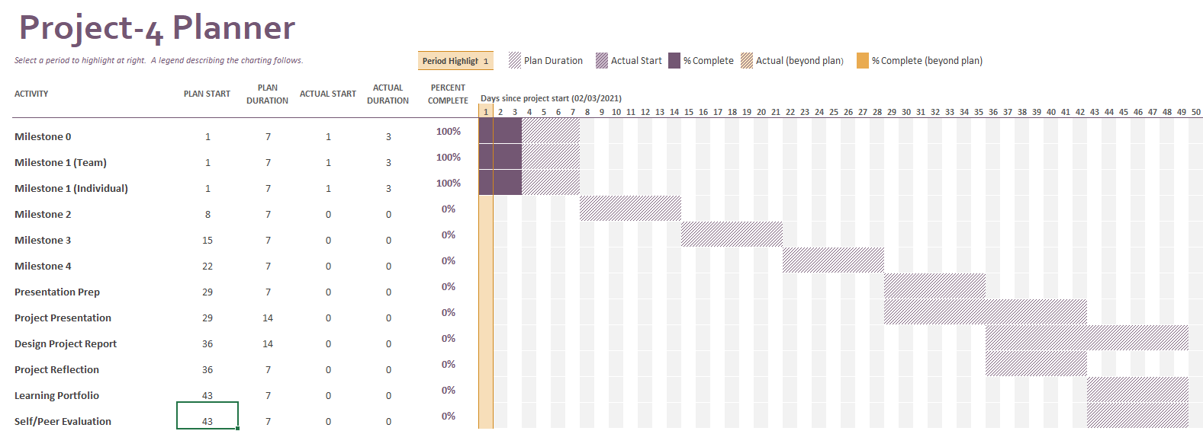

Final Gantt Chart

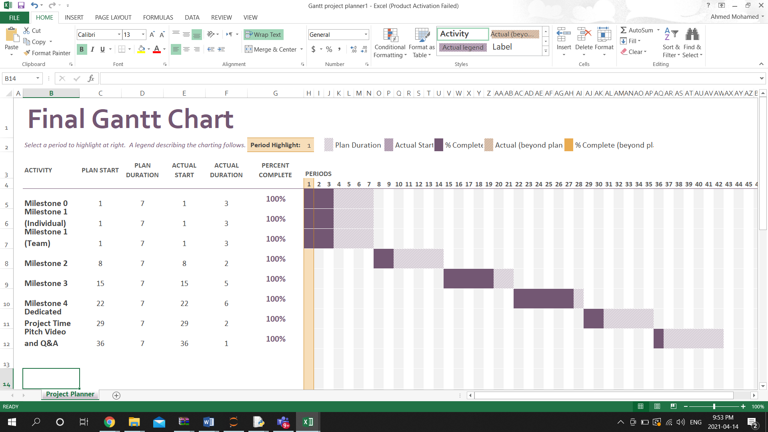

Logbook of Additional Meetings and Discussions

|  |  |  |  |
| --- | --- | --- | --- |
| Meeting Date | Meeting Topic | Meeting Length | Meeting Attendees |
| **March 29/2021** | **General Meeting** | **30m** | **Jackson Lippert, Ahmed Mohammed** |
| **April 6/2021** | **Final Deliverables** | **30m** | **Andrew Krynski, Jackson Lippert, Borna Sadeghi, Ahmed Mohammed** |
| **April 13/2021** | **Design report** | **1h 15m** | **Andrew Krynski, Jackson Lippert, Borna Sadeghi** |
| **April 15/2021** | **Finalizing design report** | **1h 45m** | **Andrew Krynski, Jackson Lippert, Borna Sadeghi, Ahmed Mohammed** |

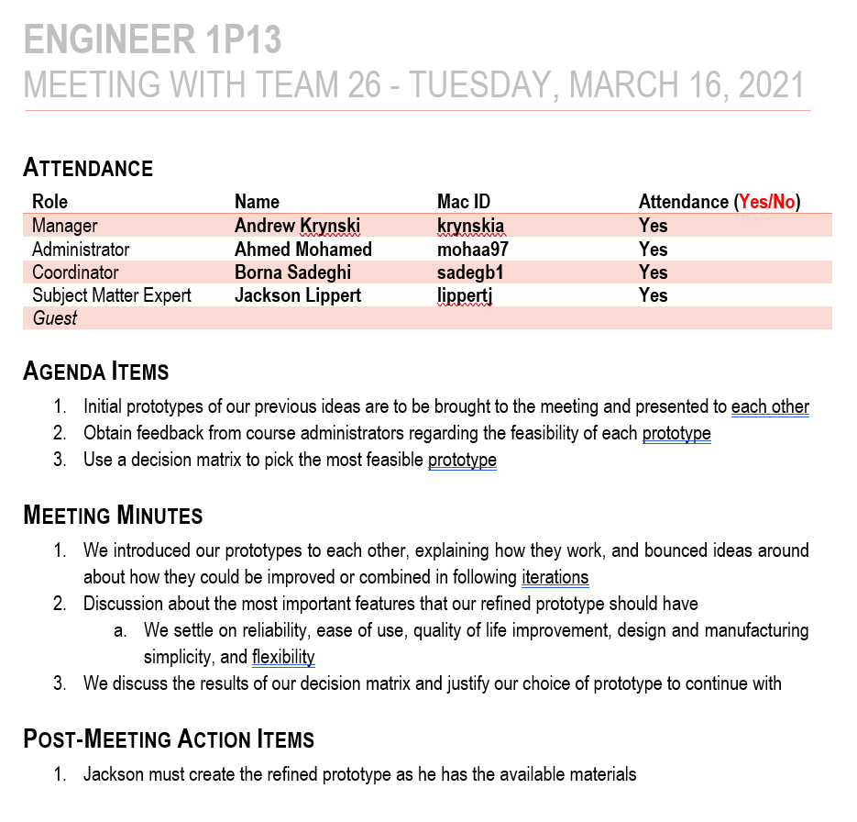

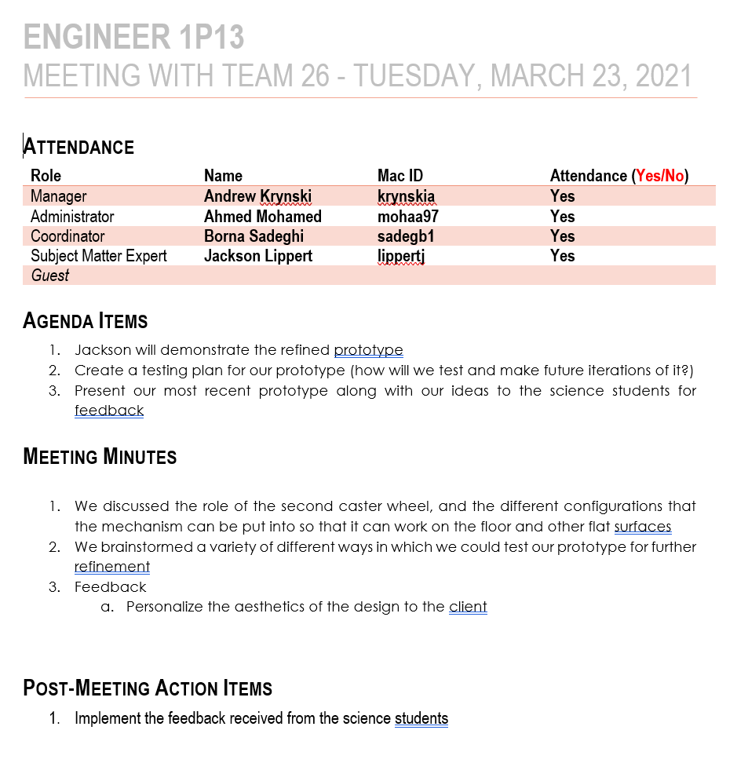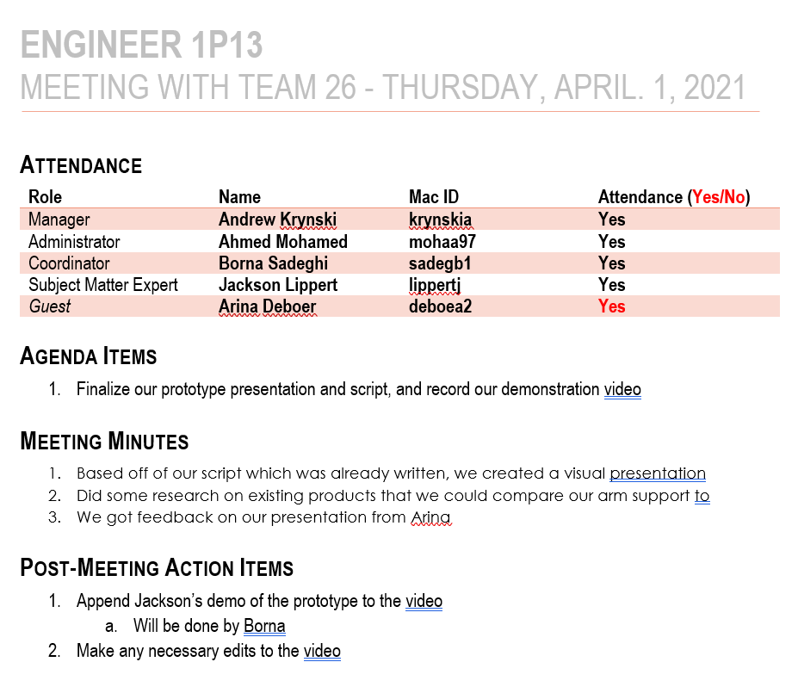

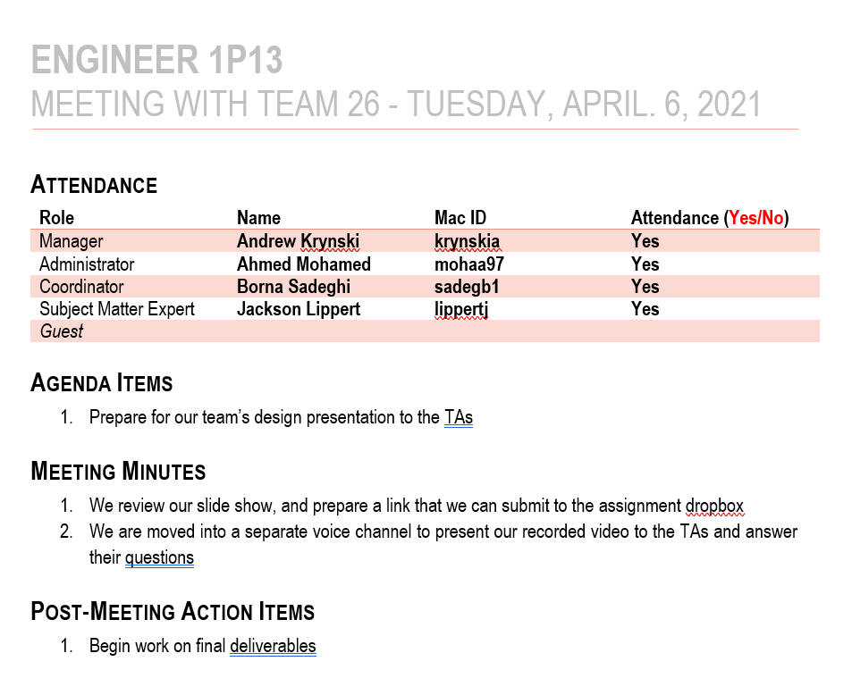

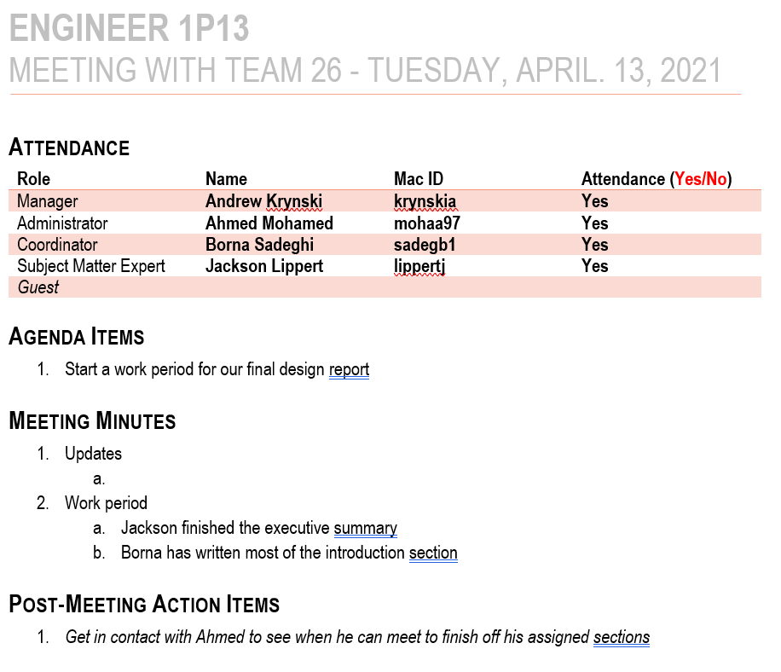

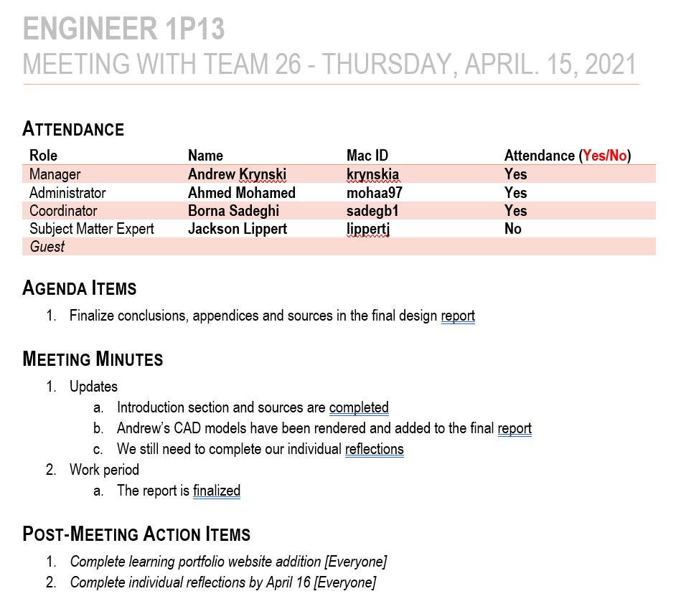

Meeting Agendas

|  |  |
| --- | --- |
| Date/Time | Agenda |
| **March 18/2021 at 12:05** | **Andrew: Introduce group**  **Ahmed and Andrew: present prototype 1**  **Jackson and Borna: present prototype 2**  **Accept feedback from reviewers** |
| **March 25/2021 at 12:05** | **Andrew: Introduce group**  **Jackson: present refined prototype**  **Borna and Ahmed: Describe inspiration**  **Andrew: Discuss future plans**  **Accept feedback from reviewers** |
| **April 6/2021 at 2:00** | **Video Presentation**  **Accept questions from evaluators**  **Give all members the opportunity to speak** |

Section 5

Source Materials Database

(Including those referenced and not referenced in this project report)

[1] Leonard Kim, “5 Hand Exercises to Help You Maintain Your Dexterity & Flexibility,” University of Southern California, (online). Available: https://uscvhh.org/news-and-stories/5-hand-exercises-to-help-you-maintain-your-dexterity-flexibility.html. [Accessed: March 8, 2021].

[2] Kristeen Cherney, “Everything You Need to Know About Fibromyalgia,” Healthline, 2020, (online). Available: https://www.healthline.com/health/fibromyalgia. [Accessed: March 8, 2021].

[3] “Hand and Wrist Pain,” Versus Arthritis, (online). Available:  https://www.versusarthritis.org/about-arthritis/conditions/hand-and-wrist-pain/. [Accessed: March 8, 2021].

[4] “Top 5 Ways to Reduce Crippling Hand Pain,” Harvard Health Publishing, 2020, (online). Available: https://www.health.harvard.edu/pain/top-5-ways-to-reduce-crippling-hand-pain. [Accessed: March 8, 2021].

[5] “Body Anatomy: Upper Extremity Muscles: The Hand Society,” *Body Anatomy: Upper Extremity Muscles | The Hand Society*. [Online]. Available: <https://www.assh.org/handcare/safety/muscles#:~:text=In%20the%20forearm%2C%20the%20FDS,finger%20(except%20the%20thumb>). [Accessed: 15-Mar-2021].

[6] “Normal Hand Anatomy Pleasanton: Hand Patient Education San Francisco,” *Tri*. [Online]. Available: <https://www.trivalleyorthopedics.com/normal-hand-anatomy/>. [Accessed: 15-Mar-2021].

[7] S. S. MBBS, “Pronation and supination,” *Kenhub*, 29-Oct-2020. [Online]. Available: https://www.kenhub.com/en/library/anatomy/pronation-and-supination. [Accessed: 15-Mar-2021].

[8] “The Wrist Joint,” *TeachMeAnatomy*. [Online]. Available: https://teachmeanatomy.info/upper-limb/joints/wrist-joint/. [Accessed: 15-Mar-2021].

[9] Michelle Petri, Pregnancy and Rheumatic Disease Clinics of North America, Vol.33, No. 2) (Rheumatic Disease ,2007. [E-book] Available: https://www.amazon.com/Pregnancy-Rheumatic-Disease-Clinics-America/dp/1416043667.

[11] J. Raymond, K. Morrow, Krause and Mahan’s Food and the Nutrition Care Process E-Book (15th ed.), 2020. [E-book] Available: <https://www.ebooks.com/en-sa/book/210014656/krause-and-mahan-s-food-and-the-nutrition-care-process-e-book/raymond-janice-l-morrow-kelly/?src=feed&gclid=Cj0KCQjwi7yCBhDJARIsAMWFScNY9RCWZOl_Izi7JI3pUJXUnFrsQf_2MracSQ9vS-5XiRu8OGBQZNIaAhkqEALw_wcB>.

[12] S. Rea, “Neurobiological Changes Explain How Mindfulness Meditation Improves Health,”.04, Feb, 2016.  Available: <https://www.cmu.edu/news/stories/archives/2016/february/meditation-changes-brain.html>. [Accessed Mar. 15, 2021].

[13] K. Huston., “Spondyloarthritis”, *American College of Rheumatology* [Online]. Available: <https://www.rheumatology.org/I-Am-A/Patient-Caregiver/Diseases-Conditions/Spondyloarthritis>. [Accessed: March 11, 2021]

[14] P. Mease, M.A. Khan. “Axial Spondyloarthritis”, *Elsevier*, 2019. Available: <https://ebookcentral.proquest.com/lib/mcmu/detail.action?docID=5720632>.

[15] P. Moglia. “Fibromyalgia.” *Magill’s Medical Guide (Online Edition)*, 2019.

[16] “Lymphedema”, *Harvard Health Publishing*. Dec. 2018.

[17] K. Johansson, K. Ochalek, and S. Hayes, “Prevention of arm lymphedema through the use of compression sleeves following breast cancer: results from a targeted literature review,” *Physical Therapy Reviews*, vol. 25, no. 4, pp. 213–218, Jul. 2020.

[18] S. Klonisch, Sobotta Clinical Atlas of Human Anatomy, one volume, English, 2019.

[19] M. Pérez-de-Heredia-Torres, R. M. Martínez-Piédrola, M. Cigarán-Méndez, R. Ortega-Santiago, C. Fernández-de-las-Peñas. “Bilateral deficits in fine motor control ability and manual dexterity in women with fibromyalgia syndrome”. Experimental Brain Research, vol. 226, pp. 137–143. January. 2013. doi: https://doi.org/10.1007/s00221-013-3417-4

[20]       Autodesk, “Autodesk Inventor Professional 2021.” Autodesk, 2021.